VPC USING NAT Gateway with correct steps
- VPC with Bastion Server
VPC & Subnet Design
VPC CIDR: 10.0.0.0/16
Public Subnet (Bastion Server): 10.0.1.0/24
Private Subnet (Database Server): 10.0.2.0/24
- Create Internet gateway
Attach week-6VPC
- Create Nategateway
- Create Route Tables
- Create RoutetablePublic
- Attach Public Subnet
- Edit Route: Attach internet gateway
- Create RouteTablePrivate
- Attach Private Subnet
- Edit Route (Add route: Destination :0.0.0.0/0 Target :Nat gateway)

- EC2 Instance Creation
Create Database Server Instance - PrivteDBserver-EC2
Subnet: Private Subnet (10.0.2.0/24)
Key pair: dbserver.pem
Operating System: Ubuntu

click on Edit near Network Settings
- VPC- week-6VPC
- Subnet : PrivateDBserver-EC2
- Add security rule :
SSH default
Type- MySQL/Aurora Source- My IP
Create Bastion Server Database Server Instance- Public-BServer-EC2

VPC- week-6VPC
Operating System: Ubuntu
Key pair: bastion.pem

Subnet: Public Subnet (10.0.1.0/24) –PublicBastionserver-EC2
Add security rule :
SSH default

Type- MySQL/Aurora Source- Private Instance IP (PrivteDBserver-EC2)

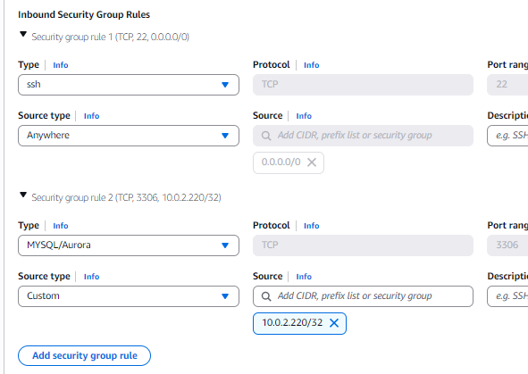

- Open powershell or go to Downloads and open Git Bash here( Git Bash choosen)
Copy DB Server Key to Bastion Server
Because: ( Database server is in private subnet. Direct SSH from local system is NOT
possible. DB server key must be copied to Bastion server)
First copy Public Bastion Instance Public IP address and paste in scp command

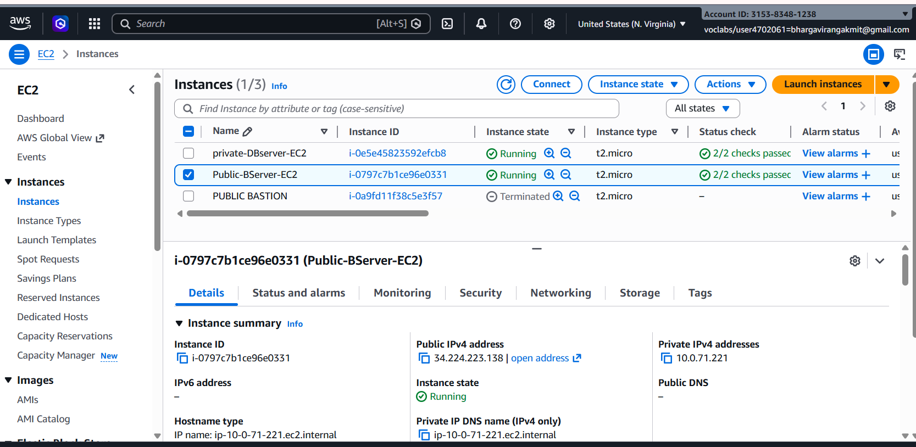

Command (PowerShell / Git Bash):
Set the path : > cd /c/Users/"BHARGAVI KUMBHAM"/Downloads
scp -i bastion.pem dbserver.pem ubuntu@ <BASTION_PUBLIC_IP>:/home/ubuntu/
example: scp -i bserver.pem dbserver.pem ubuntu@34.224.223.138:/home/ubuntu/
Copy file → to remote server → inside /home/ubuntu directory
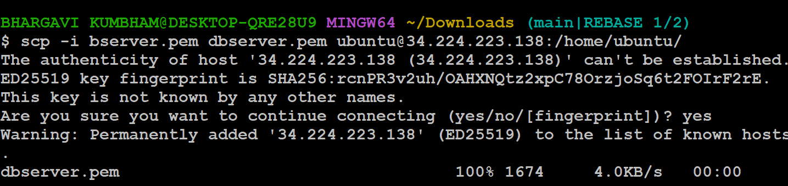

File is copied securely using SCP
dbserver.pem will now be available inside Bastion server
- Connect to Bastion Server(public ec2)
SSH Command:
ssh -i bserver.pem ubuntu@34.224.223.138
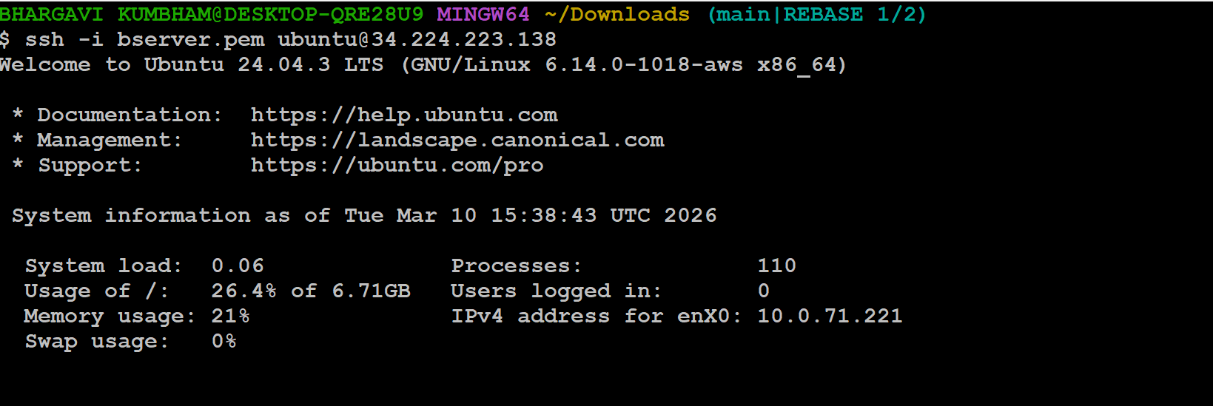
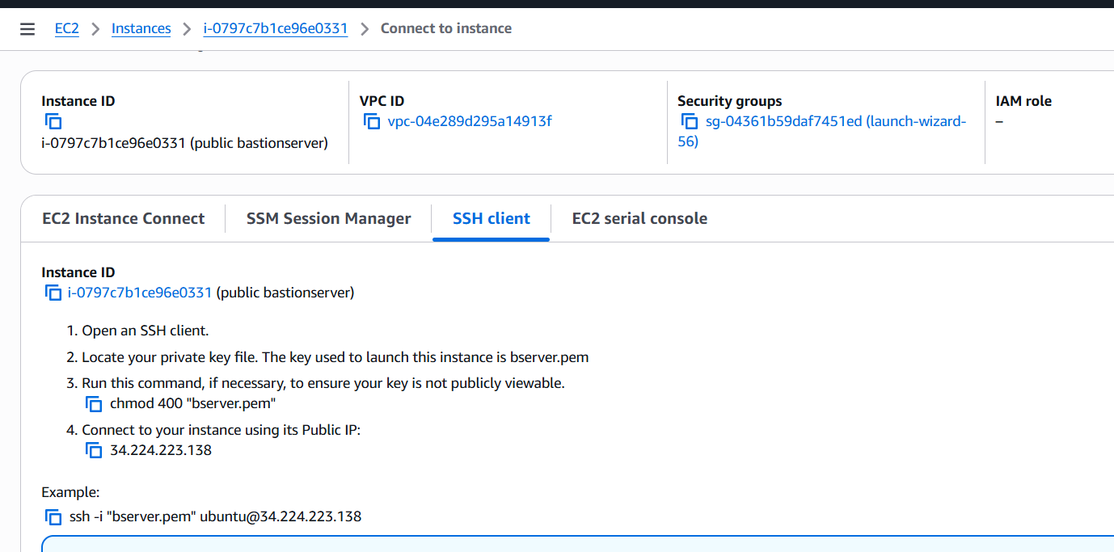

eg: ssh -i "bastion.pem" ubuntu@3.239.225.180

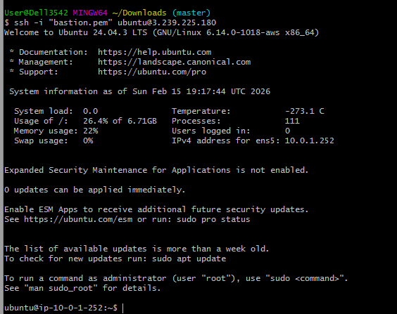

Above shows ubuntu running on public instance (at 10.0.1.252)
Verify key files:
ls
Output:
dbserver.pem

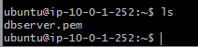

- Connect from Bastion to Database Server
- First execute in Git bash command (Important)
chmod 400 dbserver.pem
- Copy SSH of Dbserver:
ssh -i "dbserver.pem" ubuntu@10.0.2.220

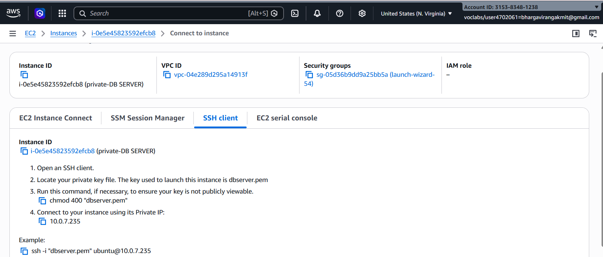
- Now SSH it from Bastion ie paste above copied SSH of dbserver into Git bash prompt.
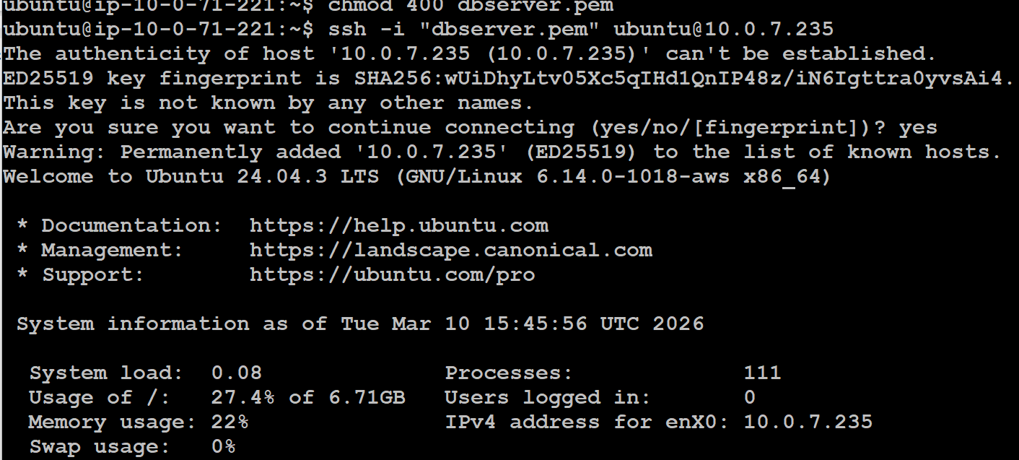
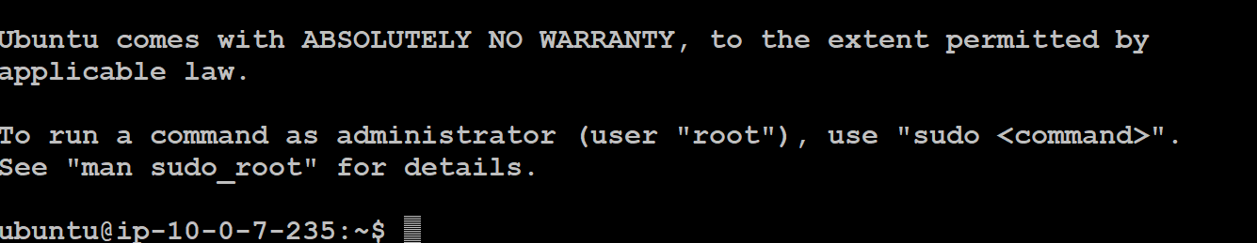

Connection to DB server is successful and ubuntu is now running from dbserver at 10.0.7.235
Logout from connection
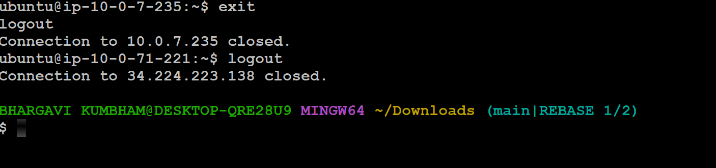

Terminate, delete, detach all.
Nat gateway delete (otherwise it cost).
Stop AWS

SCENARIO BASED QUESTIONS

- You have multiple private subnets in different AZs. Should you use one NAT Gateway or multiple NAT Gateways? Explain your design choice.
- Your private subnet instances can reach the internet, but the NAT Gateway shows no traffic.
What could be the possible reasons?
- A NAT Gateway was accidentally created in a private subnet instead of a public subnet.
What problem will occur, and how would you fix it?
- An application running in a private subnet requires outbound access only to a few trusted external services.
How would you restrict traffic while still using a NAT Gateway?
- Multiple teams share a single VPC and NAT Gateway. One team’s traffic is affecting others.
How would you redesign the NAT Gateway setup to isolate traffic?
- You can successfully SSH into a private EC2 instance using a Bastion server, but yum update / apt update fails inside the private instance. Why?
- Private EC2 instances can access the internet through a NAT Gateway, but administrators cannot SSH into them using the Bastion server.
- A Bastion server and NAT Gateway are both created in a private subnet by mistake. What impact does this cause?
- SSH access to the Bastion server works, but SSH from Bastion to the private EC2 fails. Why?
- A student claims that a Bastion server alone is enough to provide internet access to private instances. Why is Bastion not a replacement for NAT Gateway?

